Autumn has come! The new school year has begun! Our university good-naturedly opened its doors for XAMK students, teachers, freshmen, guys who came for an exchange!
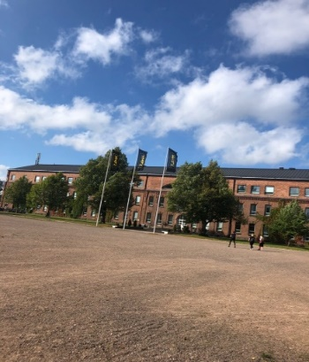Photo:Lidiia Benkovskaia
In this regard, she decided to devote the first article to a holiday that is not in Europe, but is celebrated in Russia, Armenia, Belarus, Kazakhstan, Moldova, Turkmenistan, Ukraine.
It is simply called The Day of Knowledge (1st of September)!
Knowledge Day is a celebration of the beginning of a new school year, especially for pupils, pupils, students, teachers and teachers. Traditionally, on this day, university schools host solemn rulers, performances and concerts dedicated to the beginning of the school year. Children get presents, balloons! With special solemnity they meet first-graders in schools who cross the school threshold for the first time!
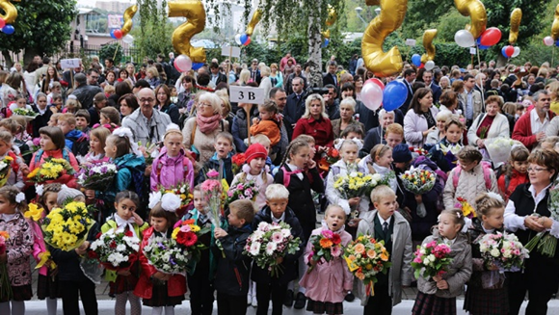 Photo: ТАСС

Short history.
1st of September is not a random date. The fact is that in Russia the New Year was celebrated on the first day of autumn. It is logical that it was from these dates that the new training cycle began. In addition, when Peter the Great postponed the New Year holidays to January 1 by his decree, it was decided to leave the beginning of studies in order not to break the usual rhythm.
The solemn line has a number of its longstanding traditions. (symbols). Here are the most important ones!
- In each school, an 11th grade student places a first grader on her shoulder, who gives the first bell that marks the beginning of the school year!
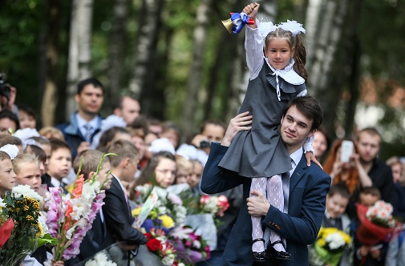 Photo: expert.ru 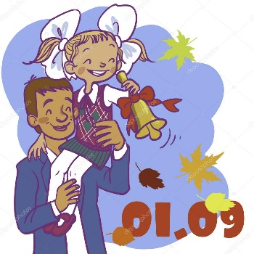 photo: depositphotos
- The eleventh graders to applause at the end of the solemn ruler, see the first graders to their first lesson in their life, they are the first to introduce children to the school!
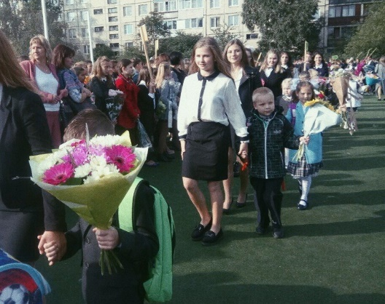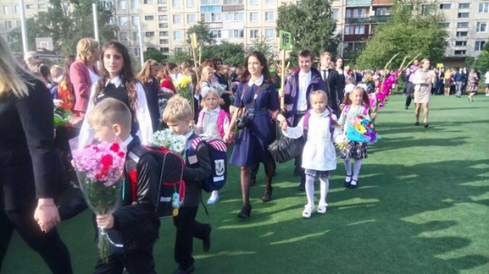
Photo:Tatiana Benkovskaia

3) The symbol of The Knowledge Day is an Autumn maple leaf and bell.
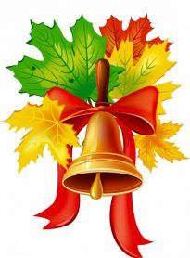 Photo: ped-kopilka.ru

